**SERVICES AGREEMENT**

KNOW ALL MEN BY THESE PRESENTS:

This Agreement is entered into by and between:

**Trimex Colleges**, a company duly organized and existing under and by virtue of the laws of the Republic of the Philippines with principal office address at **Trojan bldg. Binan, Laguna** represented herein by its Academic Head, **Carlos Batitis**, hereafter referred to as **“TRIMEX”;**

- And -

**_________________________** of legal age, Filipino, and residing at ____________, Lipa City, Batangas hereinafter called the **“SYSTEM ANALYST/DEVELOPERS”;**

WITHNESSETH: That –

WHEREAS, TRIMEX desires that the complete **Design and Implementation of “ IAttend ”, Android based attendance for Trimex Colleges** covering the computerization of the services and functionalities of the school laboratory attendance as an alternative to traditional paper and pencil attendance monitoring records for regular & training use. IAttend will be deployed using the public Internet and private intranet android-based application as its enabling technology. It was expected to be the default attendance system of the Trimex College who will be using the computer laboratories by 2019;

WHEREAS, TRIMEX engages, from time to time, the services of contractors and software vendors to provide products and services related to the development of its computer systems and applications, and the acquisition of license for the resulting software solution;

WHEREAS, the SYSTEM ANALYST/DEVELOPERS will engage in the provision of computer systems related products and services including, but not limited to, the provision of systems design, development, customization, and implementation, the granting of access for the resulting software solution;

NOW THEREFORE, for and in consideration of the foregoing premises, the parties hereto agree and stipulate as follows:

**1. INTRODUCTION**

1.1 Introduction to **Design and Implementation of “IAttend, Android based attendance for Trimex Colleges”** Project

The existence of TRIMEX COLLEGES could be very well served with following objectives: (1) To be the prime educational center in Laguna in the short-term; a reputable educational institution in CALABARZON in the medium term and one of the best to produce information technology graduates both nationally/globally, business, secretarial, education, engineering and health science school in the long turn. (2) To provide City a center that its student, parents and residents can be proud of. (3) To provide a campus where students can freely explore their talents, harness their potentials and equip themselves with the needed training for their professional careers. Thus, to ensure quality instruction, research, and community extension for the total development of technologies committed in practicing professionalism and in meeting the demands of local and national communities and to minimize the waste time of using pen and paper to monitor the student attendance, the school of CS/IT seek for a primary solution that will benefit the students and teachers.

A technology that can solve this problem and even do more is the Quick Response Code (QR Code) technology. QR Code is an automated identification and data collection technology, that ensures more accurate and timely data entry. QR Code is not actually a new technology; it only quickly gained more attention recently because of its current low cost and advances in other computing fields that open up more application areas. QR code main advantage was its high data encoding capacity: The maximum QR code symbol has the ability to encode about 7089 characters, High-speed scanning and reading: a QR code reader has the ability to recognize many QR code symbols, read fast and it also can be read from any direction: Since it is a 2D matrix code, it can be scanned and read from any direction.

While the “best” attendance monitoring system till date was facial recognition system, It has a extremely high cost in equipment and database which resulted in a very high initial cost that is not feasible. Of course there are other factoring methods that don't require a big investment but it was not yet proven the best. So, the CS/IT department concluded that QR code was the best applicable system for their laboratory attendance.

Furthermore, The CS/IT department significantly embraces the fact that to easily manage and monitor the implementation of majority of its services, a technologically-advanced academic community forms part of its mission. To contribute to its realization, the utilization of current technologies and technology-driven processes are deeply supported. This is where the idea of designing and implementing an **Android based attendance Application for Timex Colleges Project** ascended.

IAttend main objective is to develop and implement a mobile application system that uses Quick Response Code (QR Code) Data compression algorithms as an alternative to traditional paper and pencil attendance monitoring

In machine learning, there’s something called the “No Free Lunch” theorem. In a nutshell, it states that no one algorithm works best for every problem, and it’s especially relevant for supervised learning, so the team decide to use 2 algorithms which is called data compression algorithm and QR Code Generation algorithm to make a better mobile application.

The College of CS/IT department will be the main department involve in the System. The department will be working together to implement IAttend. The CS/IT department will be referred here as “Department”.

1.2 Scope of Work to be provided

1.2.1 The System Analyst/Developers shall undertake the analysis, customization and installation of the iAttend system, and conduct user’s training for a pilot group composed of the participants/representatives nominated, hired or otherwise contracted by TRIMEX.

1.2.2 The complete iAttend system will have the following modules, 2 Users, and 2 algorithms.

* 1. **Modules**
     1. **Student’s** 
        1. Attendance
        2. Attendance Viewing
     2. **Instructor’s** 
        1. Generation of QR Code for Attendance
        2. Student’s Attendance Management
        3. Student’s Attendance Report
        4. Login Module
     3. **Server side**
        1. Attendance Confirmation (SMS)
  2. **Users**
     1. **Student -** this user can:
        1. Set an attendance by just scanning the QR Code
        2. View attendance history per subject
     2. **Instructor** - this user can:
        1. Generate QR Code that will serve as attendance for student upon scanning
        2. View student’s attendance for certain subject
        3. Manually encode student’s attendance if the student doesn’t have an android device
        4. Automatically compute student’s grade for their attendance
        5. Generate report that consolidate student’s attendance per subject.
  3. **Algorithm**

c.aQR Code Generation Algorithms: (GenQR)

STEP 1: Start

STEP 2: Input the source file (infile)

STEP 3: Call GenSig (infile)

STEP 4: Compress 'suepk','sig' and 'infile' into 'test.zip' file

STEP 5: Create an empty string data

STEP 6: Convert 'test.zip' into string and store in 'data'

STEP 7: Input the image format and resolution of the QR Code to be generated

STEP 8: Input Error Correction Level

STEP 9: Using data compression method convert 'data' into a BitMatrix object 'bitmatrix'

STEP 10: Write bitmatrix to an image

STEP 11: End

c.b QR Code Decoding Algorithm: (Decode_QR)

STEP 1: Start

STEP 2: Input QR Code image

STEP 3: Construct a Binary Bitmap object 'bitmap' from source image

STEP 4: Using zxing library method decode the 'bitmap' and store it in the object 'result'

STEP 5: Convert 'result' into string and write it to 'result.zip'.

STEP 6: Extract result.zip

STEP 7: If requested by user call the information

STEP 6: End

|  |  |
| --- | --- |
| System Phase | Deliverables |
| Phase 1 | * **Infrastructure setup** * **Integration of iAttend to Trimex’s Grading System database** * **Modules:**   Student   * 1. **Attendance Module** – This module will allow student to automatically set an attendance to a subject by just scanning the QR Code provided by the subject’s instructor   2. **Attendance Viewing Module -** This will allow the student to view their attendances record to a certain subject   Instructor   * 1. **QR Code Generation Module** - This module focus on generating unique QR Code (per subject, instructor, room and date) that will be scanned by the student.   2. **Student’s Attendance Management Module** - This module will allow the instructor to view each student’s attendance (per subject) as well as manually encoding of student’s attendance if the student does not have or has no available android device.   3. **Login Module** |
| Phase 2 | * **SMS Module –** A module that will automatically notify student’s guardian/parents through SMS, once the student attended his/her subjects. * **Report Module**   + ***Student’s Attendance Report -*** *Generate report that consolidate student’s attendance per subject.* |

As part of the requirement definition phase for the features, the Systems Requirement Report (SRR) to be submitted by the System Analyst/Developers to TRIMEX shall contain the detailed specification of the work to be done and functions to be delivered, in accordance with the above scope.

1.3 Scope of Work to be excluded

The following are not included in the scope of this project:

1.3.1 IOS and WEB version of the application.

1.3.2Any work necessary to support messages, functions or data sets not listed above in the scope of the project.

1.3.3 Provision for server, hardware, third party licensed software (operating systems, SQL Server, etc.), supplies, ISP connection and other network facilities and hardware needed.

1.3.4 Installation, configuration, administration, and/or maintenance of TRIMEX network and servers (web, validation, proxy, SQL, etc.) where the web hosted application system may/will be connected to, except for the initial install and production database.

1.3.5 Subsequent revision of functionality and/or re-layout of the screens and reports compromising the application, after the workflow and design presentation was approved during prototyping session.

1.3.6Limited for CS/IT Department’s WEP student who will be using laboratory.

**2. DELIVERABLES**

2.1 Formal Deliverables and Team Working Papers

The System Analyst/Developers shall undertake the project by phases and generate deliverables based on its standard systems development methodology, whenever applicable, as follows:

|  |  |
| --- | --- |
| **Project Phase** | **Deliverables** |
| 1. Project Organization | Project Work Plan  Project Team (*See Section 6.3*) |
| 1. Requirement Definition | Systems Requirements Report  (*Appendix A*) |
| 1. Analysis and Design | System Model  User Acceptance Test Plan (*Appendix B*) |
| 1. Initial Development (Code and Test) | System Prototype  Tested Partial System for Pilot Testing |
| 1. Pilot User Training and Installation | Trained Pilot Users |
| 1. Continue Development (Code and Test) | Tested System |
| 1. Documentation | User’s Manual (*Appendix C*)  System Specification (*Appendix D*) |
| 1. Final User Training and Installation | Trained Users |
| 1. Integration Test / User Acceptance | Signed Acceptance Certificate (*Appendix E*) |

2.2 Non-Formal Deliverables

The System Analyst/Developers will see to it that iAttend system will possess the required standards in relation to usability, reliability, performance, supportability, implementation, interface, packaging and legal requirements.

2.3 Related Plans

The iAttend system will be built to integrate with the technology that fits and compatible for the requirements. The system will be build using C# API, Xamarin mobile and Microsoft SQL Server.

2.4 Standards and Procedures

2.4.1 All policies and procedures shall be provided by TRIMEX to the System Analyst/Developers.

2.4.2 The System Analyst/Developers may introduce or recommend procedures to fully utilize the functionality of the iAttend system subject to approval of TRIMEX.

**3. METHODOLOGY AND APPROACH**

3.1 Work Breakdown Structure

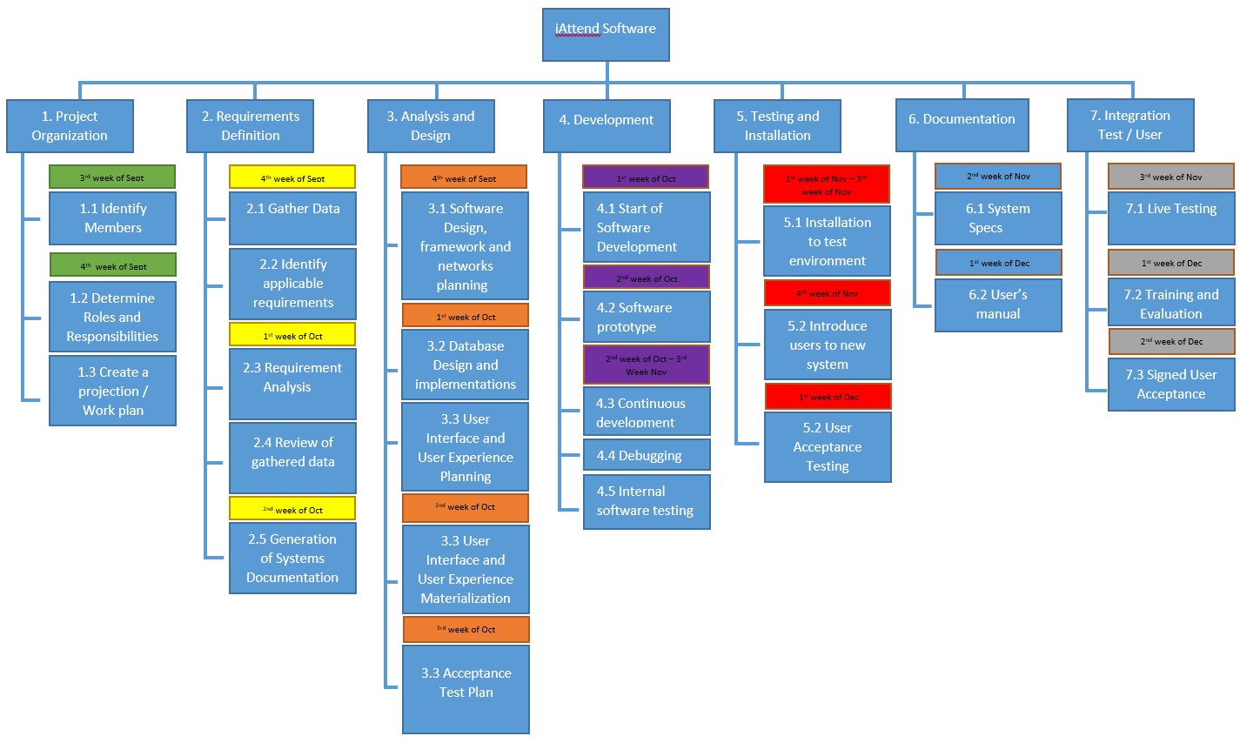

3.2 Tools and Techniques

The System Analyst/Developers will use the Gantt chart and Milestones as tools in this project. Details are as shown in Section 5.

3.3 Physical Inventory/Configuration Management

The iAttend system will require the following hardware specification:

Android Device (4.0 and above) with working Camera (for Student and Instructor)

Desktop for Windows 10 (UWP) (Instructor only)

Internet Connection / Ethernet/ Network

Server

Processor: Intel INTEL i5 2nd Gen or higher

Memory: 4 GB

Hard Disk Size: 250GB

OS: Windows 10 (Build 17134 (version 1803)) and above

Clients

Smartphone: Android

Operating System: Ice Cream Sandwich (4.0) & Above

Hardware: Camera at least 4Megapixels

**4. PROJECT BUDGET**

The total cost of undertaking this systems development project will be shouldered by the System Analyst/Developers as part of their requirements for the Advanced System, Analysis and Design subject.

However, the cost for third party software, hardware equipment, telecommunications, Internet connection, and hosting services will be provided by TRIMEX.

**5. PROJECT SCHEDULE**

5.1 Schedule

Initial pilot implementation work shall be conducted in accordance with the following estimated schedule below for the modules identified from Section 1.2 (Phase 1) and shall continue based on subsequent and mutual coordination between both parties during the course of its performance.

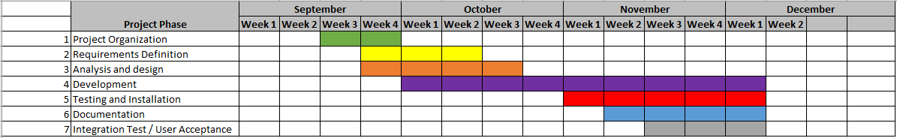

5.2 Major Milestones

Major milestones shall be documented and must comply with the schedule of the project. Each project phase shall be specifically mark along with the project timeline to determine if the project is on schedule. Major milestones will be populated in Appendix F.

**6. PROJECT ORGANIZATION**

6.1 TRIMEX C.S/I.T Department Organization

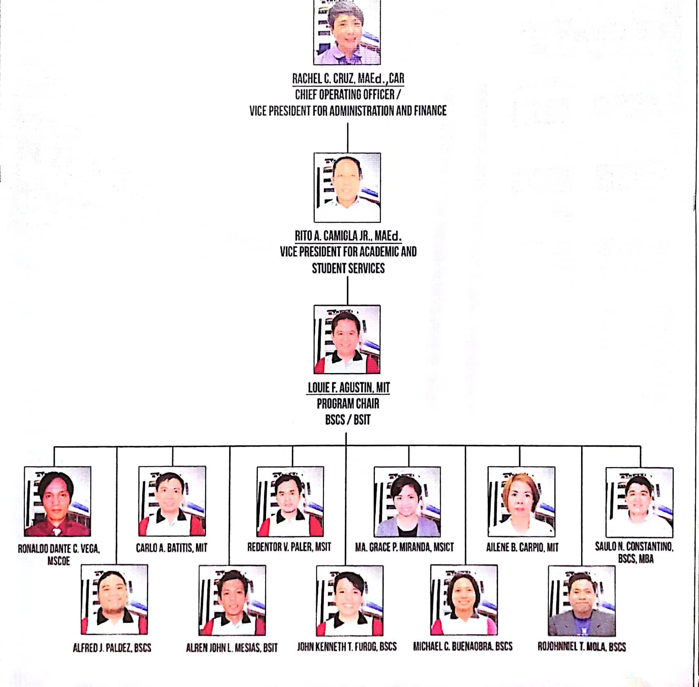

6.2 Development Organization

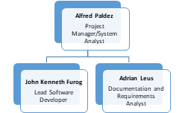

6.3 Conceptual Models

6.3.1 Conceptual Model of Encoding

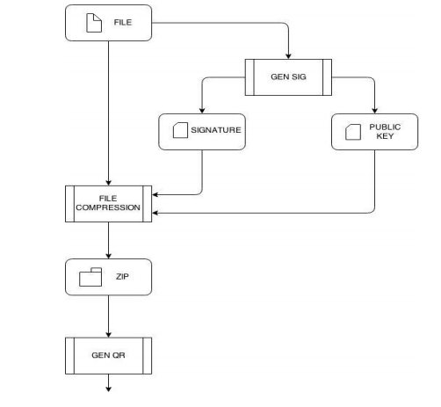

6.3.2 Conceptual Model of Decoding

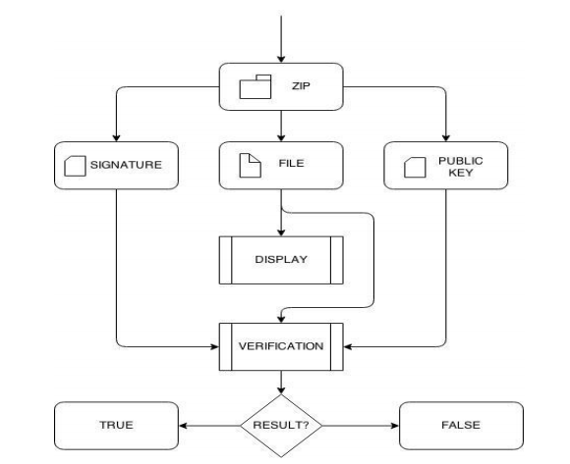

Above diagrams show the conceptual model of how the QR decodes. Decoding the QR Code and verification system are developed to work in Android mobile environment.

6.3.3 Result

* Data relevant for student’s attendance such as:
  + Instructor ID number
  + Subject Code
  + Classroom
  + Subject Time
  + Student’s master list for that specific subject

6.4 Responsibility Assignment Matrix

|  |  |  |
| --- | --- | --- |
| **Role** | **Responsibilities** | **Participants** |
| Project Sponsor | * Decision maker * Project oversight * Review and approve some requirements in the project. | Trimex Colleges, Dean of College Studies, IT Dept. Head |
| System Analyst/Developers | * Provide overall project direction * Manages Project in accordance to the project plan * Resolve conflict and issues * Serves as liaison to the Steering Committee * Receive guidance from Steering Committee * Lead team members towards project objectives * Handle problem resolution | Alfred Paldez  (Proj. Manager)  Adrian Leus  (Requirements Analyst)  John Kenneth Furog  (Lead software Developer) |
| Project Participants | * Define the user requirements and the process and procedures of their department. * Review and approve project deliverables. * Coordinates participation of users and stakeholders. * Provide knowledge and recommendations. * Helps identify and remove project barriers. | Trimex Colleges IT. Dept Head, Faculty & students  Project Manager, Requirements Analyst and Software Developer |

**7. ASSUMPTIONS**

The following assumptions were made in preparing the Project Plan:

7.1 TRIMEX is willing to change the departments’ process to take advantage of the functionality offered by the iAttend.

7.2 The Project Manager will ensure that project team members are available as needed to complete project on time based on the project schedule in Section 5.1.

7.3 The Project Manager will make sure that the team members are updated if changes will be made in the project plan.

7.4 Failure to identify changes in the deliverables during the requirement definition as shown Section 5.1, will result in incremental development delays.

7.5 TRIMEX will provide the clean data or the data without the inaccurate records for migration if necessary. The Project Manager will provide assistance in converting the data to a usable data for iAttend.

7.6 The project manager will provide a user acceptance report before implementing the iAttend system.

7.7 TRIMEX will provide a test environment before the iAttend system be installed in a live infrastructure.

7.8 TRIMEX will ensure the existence of a network infrastructure to support the iAttend system and ensure that the Steering Committee will participate in the timely execution of the Project Plan.

7.9 TRIMEX is the owner of workstations, test and live servers, and all other equipment in its premise.

**8. RISKS**

A risk assessment will be provided by the Project Manager. The assessment will include the following entries to identify the risks. (*Appendix G*)

* Vulnerability
* Threat
* Risk
* Likelihood
* Impact
* and Recommendations

**9. RESPONSIBILITY OF TRIMEX**

9.1 TRIMEX shall assign a Steering Committee who shall review and approve all project deliverables submitted by the Project Manager as defined.

9.2 TRIMEX shall provide a location for development and testing of the system. During the integration, it is the responsibility of TRIMEX to secure all the data. This is to ensure the reliability of the data.

9.3 TRIMEX shall make available all personnel required to be interviewed at designated periods as agreed upon during the project organization phase.

9.4 TRIMEX shall review and approve all the deliverables prior to implementing the iAttend system.

9.5 TRIMEX may cancel the project if the deliverables have not been met by the Project Manager only if the cause of the events is the development team. However, any cost that has been paid is not refundable.

9.6 TRIMEX shall provide an area where the development team will work on. At least (1) workstation equipped with network capabilities required by the Project Manager.

9.7 TRIMEX shall schedule a testing of the system with the project participants and users once the Project Manager requested to do the assessment of the system.

9.8 TRIMEX shall make available all records and documents, and any existing computer applications or message design necessary for the development project.

9.9 TRIMEX shall provide the Project Manager all the current and planned policies and procedure of the departments.

**10. TERMS OF ACCEPTANCE**

10.1 This agreement is a complete and sole statement of understanding between the Project Manager and TRIMEX on this subject matter. All other prior commitments, representatives, writing and discussions are superseded.

10.2 The Project Manager reserves all proprietary right and interest to the core application of the e-iAttend system. However, all specifications and documentation relating to customization of the application specific to TRIMEX shall be exclusive property of TRIMEX.

10.3 The Project Manager shall warrant the system to be free from any program bugs or error for a period of twelve (6) months from the date of installation and commencement of earliest pilot operation. Any bugs or errors that may arise within the warranty period shall be corrected by the Project Manager at no charge to TRIMEX provided that the programs remain in the original state. However, if the system problem is due to TRIMEX’s fault, or the failure of any other hardware or systems component not supplied by the Project Manager within the scope of this agreement, the Project Manager shall provide system analysis and programming resources at TRIMEX’s cost.

**11. CHANGE CONTROL, DECISION CONTROL, AND FAULT REPORTS**

11.1 TRIMEX can request for a change on the process provided it will not affect the project as a whole. To file for a request, TRIMEX shall use a change and/or decision control form (*Appendix H*) provided by the Project Manager. It must also be signed by at least one (1) person from the Steering Committee.

11.2 Any faults found the iAttend system shall be reported using a fault report (*Appendix H*). The fault report must also be signed by at least one (1) person from the Steering Committee.

11.3 The Project Manager shall determine the impact of the changes, decisions and/or faults to the iAttend system. It may be approved by the Steering Committee but the Project Manager shall have the final approval for the requests.

**12. STATUS REPORTING**

12.1 The Project Manager shall provide status report (*Appendix I*) to the Steering Committee and Project Participants at least twice a month. Status report shall be provided at the end of the working day every week. Status may comprise of the status on the deliverables, schedule and the development until the system is implemented.

12.2 To ensure that all deliverables and schedules are on track, the Project Manager hereby requests a monthly meeting to the Steering Committee every last Friday of the month or as the need arises.

**14. AUTHORIZATION**

**IN WITNESS WHEREOF**, the parties have signed the Agreement on the date and place indicated.

**IAttend Project**

__________________________ __________________________

**MR. ALFRED PALDEZ J.K FUROG, ADRIAN LEUS**

Project Manager Requirements Analyst/Lead Developer

__________________________ __________________________

Date Signed Date Signed

Signed in the Presence Of:



____________________________________________________

**MR. CARLO A. BATITIS**

COMPUTER SCIENCE PROGRAM CHAIR

APPENDIX A: SYSTEMS REQUIREMENT REPORT

APPENDIX B: USER ACCEPTANCE TEST PLAN

APPENDIX C: USER’S MANUAL

APPENDIX D: SYSTEM SPECIFICATION

APPENDIX E: ACCEPTANCE CERTIFICATE

APPENDIX F: MAJOR MILESTONES

APPENDIX G: RISKS ASSESSMENT

APPENDIX H: CHANGE/DECISION CONTROL AND FAULT RPORT

APPENDIX I: STATUS REPORT

APPENDIX J: FUNDING